**Testing Concepts**

Lesson 01 : Fundamentals of Testing

Software Testing:

Software Testing is the process of executing a program with the intent of finding errors as early as possible in SDLC. It is a process used to help identify the correctness, completeness and quality of a developed computer software

Why is testing becoming such a crucial activity?

Because applications are becoming very complex with n-tiers in an application. When one tests a program one adds value to it through improved quality and reliability. If not tested it can cause an unpleasant navigational error in case of a browsing applications or death or injury in case of safety critical applications. End customers are becoming more demanding & conscious about quality.

Cost of Software Defects:

The cost of fixing a bug (defect) and making the required changes in early phases of software development is less as compared to the same detected in later phases since cost is spent at four different times in a SDLC;

Importance of Testing Early in SDLC Phases:

Many problems raise during planning or design. Requirements testing can prevent future problems thus lowering the cost.Since the testing process is involved with all phases of the SDLC, Management will not feel as if testing is a bottleneck to release the product. Test cases written during requirements and shared with the Dev. team before the construction phase can help developers to reduce the chances of failure. The test environment can be prepared in advance. The risk of having a short time for testing is greatly reduced

Testing & Quality:

Testing helps to measure the Quality of software in terms of number of defects found & I important information regarding the Non functional attributes like Reliability, Security, Performance, etc.

Quality Definition:

Conformance to explicitly stated functional and performance requirements, explicitly documented development standards and implicit characteristics that are expected from all professionally developed software.

Software Testing Principles:

Principle 1 - Testing shows presence of defects but cannot prove that there are no defects

Principle 2 - Exhaustive testing is impossible

Principle 3 - Early testing

Principle 4 - Defect Clustering

Principle 5 - Pesticide Paradox

Principle 6 - Testing is context dependent

Principle 7 - Absence of Errors fallacy

How testing is conducted?

Testing is conducted with the help of users requirements, design documents, functionality, internal structures & design, by executing code.

Scope of Software Testing:

“Understanding risk is the key to Optimum testing”. Factors like Contractual requirements, Legal requirements, Industry-specific requirements affects the scope of testing

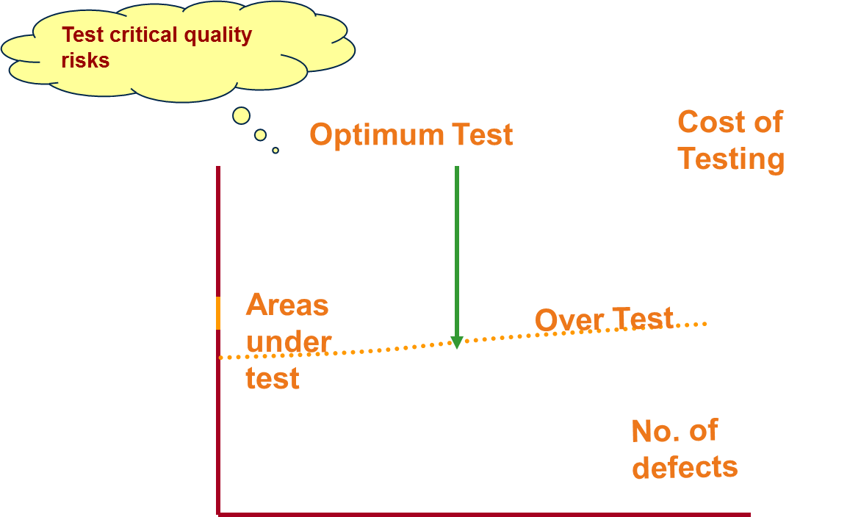

Risk based testing:

Risk based Testing is used to reduce risk of adverse effect occurring or to reduce the impact of adverse effect

Need of Independent Testing:

* Unbiased testing is necessary to objectively evaluate quality of a software
* Developer carrying out testing would not like to expose defects
* Assumptions made are carried into testing
* People see what they want to see.
* More effective in terms of Quality & Cost

Activities in Fundamental Test Process:

**Test planning and control:** It defines the objectives and specification of test activities

**Test analysis and design:** Testing objectives are transformed into tangible test conditions and test cases. Creating bi-directional traceability between test basis and test cases

**Test implementation and execution:** Test procedures (scripts) are specified by combining test cases in a particular order and the environment is set up and tests are run. Executing test procedure using tool or manually according to the planned sequence. Logging the outcome of the test execution and reporting discrepancies and analysing their root cause.

**Evaluating exit criteria and reporting:** Test execution is assessed against the defined objectives. Test logs and checked against the exit criteria specified in test planning. Assessment is done if more tests are needed. Test summary report is written

**Test closure activities:** Data from completed test activity is collected to consolidate experience, facts and numbers.

Code of ethics for testers:

Involvement in software testing enables individuals to learn confidential and privileged information. A code of ethics is therefore necessary, among other reasons to ensure that the information is not put to inappropriate use.

Limitation of Software Testing:

Even if we could generate the input, run the tests, and evaluate the output, we would not detect all faults. Correctness is not checked . The programmer may have misinterpreted the specs, the specs may have misinterpreted the requirements. There is no way to find missing paths due to coding errors.